Modify the /etc/ssh/sshd_config file:

PasswordAuthentication yes

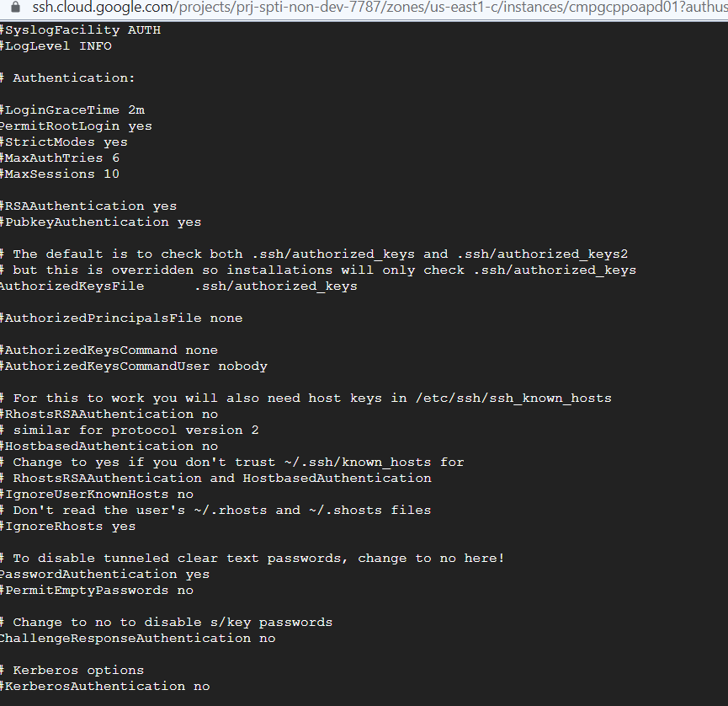

**Restart ssh**

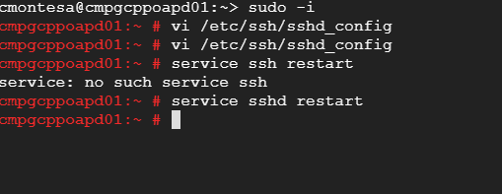

**Create user**

sudo useradd -m username

sudo passwd username

sudo usermod -a -G wheel docampo

visudo

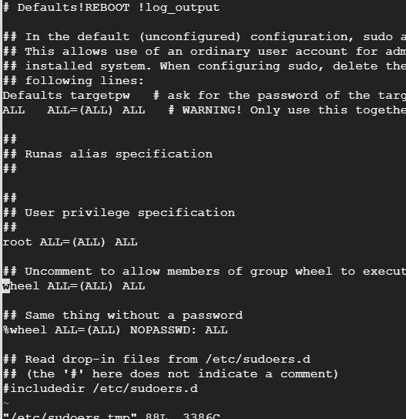

**Comprobar los privilegios del nuevo usuario:**

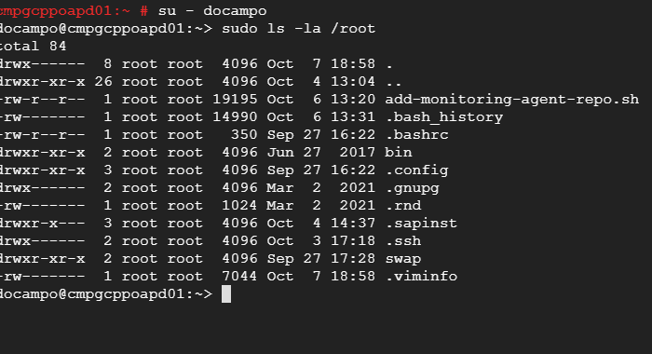

<https://www.digitalocean.com/community/tutorials/how-to-create-a-sudo-user-on-ubuntu-quickstart>

<https://www.shellhacks.com/how-to-grant-root-access-user-root-privileges-linux/>

<https://www.pluralsight.com/blog/tutorials/linux-add-user-command>

<https://linuxize.com/post/how-to-create-users-in-linux-using-the-useradd-command/>

<https://infoheap.com/linux-ssh-enable-password-login/>